Leave Request:

Issue1 : Supervisor can approve for the leave request for the date range greater than the terminate date for terminated employee

1>Employee#101191(Supervisor :100757) was terminated with termination date as 3/10/2019 and remains in inactive or terminated state

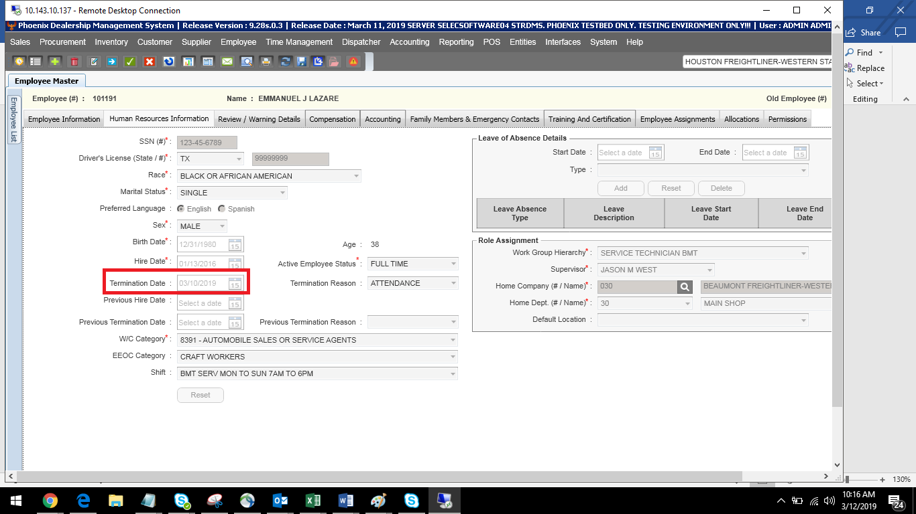

2>But, Supervisor was able to approve the leave request for the future date <date greater than termination date > without any validation

